Brushed DC and Stepper Motor Control

# Project Description

This project should serve as an introduction to different control schemes for two types of DC motors: a brushed DC motor using feedback, and a feed-forward (without feedback) stepper motor.

# Background

## Different Types of DC Motors

You will encounter two types of DC motors in this lab: a PWM-controlled commutated --or “brushed” motor-- and a stepper motor. Naturally, each has its own advantages and disadvantages that suit them to specific applications.

### Terminology

To understand the following descriptions of DC motors, a review of the terminology used is essential. All motors have a rotating part, called the “rotor”, and a stationary part, called the “stator.” These terms refer to the mechanical aspect of the motor, generator, or dynamo. Though often used interchangeably, the term “armature” is different: it represents the component or assembly carrying current. The other component is the “field”, the component or assembly creating magnetic flux that interacts with the armature, allowing rotation to take place (source: [American Society of Power Engineers](http://www.asope.org/pdfs/AC_Electrical_Generators_ASOPE.pdf)). Field, in this case, refers to either field windings that create flux only when external voltage is applied, or permanent magnets, which have static flux. Fields and armatures can be located on either the rotor or the stator, which is why this topic demands keeping the mechanical aspect separate from the electrical.

### Brushed DC Motors

The commutated or “brushed” DC motor is the most common variety. Without delving too deeply into the details, it is named such because it uses a mechanism called a commutator with sliding “brush” contacts to change the direction of current flow through the rotor windings as they turn. This is needed because the loops carrying current are rotating, but the field magnets are not; as the rotor turns, the current must be reversed so the torque will maintain its direction. A diagram depicting the internal mechanism of a brushed DC motor is shown in Figure 1.

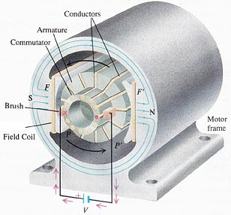

Figure : Brushed DC Motor Internals ([Source](http://www.industrial-electronics.com/univ_physics_28-8.html)).

This type of motor has a constant current draw when a constant DC voltage is applied to the motor terminals. The direction of rotation can be reversed by reversing the polarity of the terminal connections. In order to vary the power level of a constant-voltage device, Pulse-Width Modulation (PWM) can be used. In this case, the PWM signal will actuate a separate motor driver IC. Increasing the pulse-width increases the speed of rotation, and decreasing it will reduce the speed of rotation.

### Stepper Motors

A stepper motor shaft moves in discrete increments in response to digital pulse sequences applied from a controller. The stepper motor incorporates multiple windings to make the stepping behavior possible. Depending on their how the stator (stationary part) and the rotor (moving part) are designed, stepper motors are classified into three types: variable reluctance , permanent magnet, and hybrid. A variable reluctance motor has a soft iron, non magnetized, and a multi-toothed rotor. Permanent magnet motors have a magnetized rotor with no teeth. Hybrid stepper motors are by far the most common and combine features from both variable reluctance and permanent magnet steppers to produce a machine with the ability to produce high torque at low and high speeds with very fine resolution.

The rotor is turned by energizing stator coils on opposite sides of the rotor, inducing a magnetic field in the rotor, causing the rotor field to align with the stator field. This is known as one “step.” The need to induce a magnetic field in the rotor makes it less efficient than the brushed motor. To rotate, the set of energized coils must vary to produce several “steps;” this is why it is known as a “stepper” motor. It will not rotate with a constant DC voltage applied to its terminals, but instead requires the coils to be energized in a specific pattern to step the rotor.

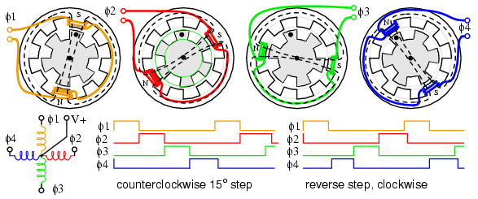

Figure : Unipolar Stepper Motor Process.

Figure 2 depicts a unipolar stepper motor, meaning only one pair of coils is energized at a time. Bipolar motors energize two at a time, and allow smaller steps, but the process is the same. For a stepper motor, a driver IC or microcontroller is required to step at a rate fast enough to be considered useful. The precise locations of the rotor and stator teeth define the angle for each step, and allow the stepper motor to be controlled very precisely. This makes it useful for position control systems in robotics and automation. The brushed motor, on the other hand, can achieve much higher revolutions per minute (RPM) with greater torque, but is less precise.

## Motor Drivers

Most DC motors can be modeled as an RL circuit with relatively low resistance, but large inductance. Because of this, they draw a substantial amount of current. This current is almost always more than a microcontroller can supply, therefore the controller generally interfaces to a motor driver IC. The IC’s specific functionality can vary depending on the motor in use, but will always act as an intermediary between the low-current domain of the microcontroller pins and the high-current domain of the motor and supply. This is done using a structure called an H-bridge, made of four MOSFETS. The H-bridge not only allows control of a higher-current load, but also allows a change in direction by activating different pairs of MOSFETs. Figure 3 shows the actuation patterns for an H-bridge connected to a motor M, with the encircled MOSFETs representing *active* switches/transistors. Diagram t1 shows forward operation, with current flowing one way. To reverse the direction, all four transistors should be inverted. Diagram t3 describes the braking condition, called “short brake” because each terminal of the motor is shorted to ground. This is an effective braking system because any back-EMF generated by rotation of the motor causes a current that runs the motor in the opposite direction, forcing the rotor to a stop.

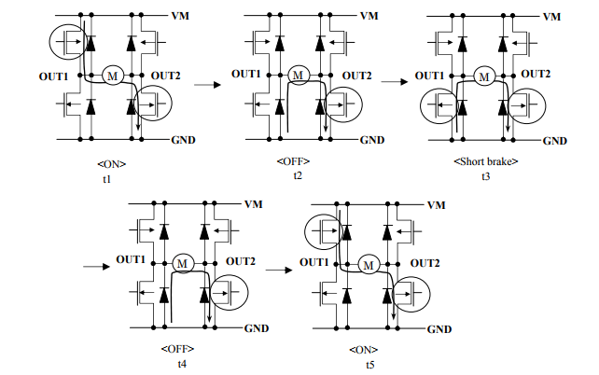

Figure : H-Bridge Circuit under Various Conditions.

Note that diagrams t2 and t3 in Figure 3 produce the same effect, despite one MOSFET not being active. This is because of the bypass diodes, which are necessary in any motor control application. To understand why, consider the equivalent circuit of a DC motor, as shown in Figure 4.

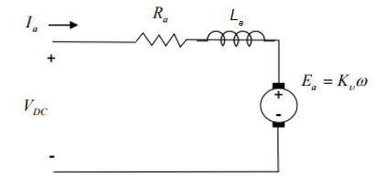

Figure : Equivalent Circuit of a DC Motor.

The construction of a DC motor entails a coil of wire, which, by definition, is an inductor. The armature of the motor (the assembly of rotor and commutator) is effectively a generator. When rotation is applied, voltage is produced across it; likewise, when voltage is applied, rotation is produced. This is the origin of the saying: “A motor is a generator is a motor…” The constant Kv includes the geometry of the motor and magnetic flux within. Note that with a permanent magnet motor, the flux will be constant, and thus the voltage across the armature is directly proportional to the rotation.

With this generator and inductor configuration in the H-bridge circuit, consider what happens if the motor is running and the MOSFETs turn off. Because an inductor cannot immediately cease current flow, the current would be pulled from ground through the bypass diodes. Were the diodes not there, immediately opening the circuit by turning off a MOSFET would cause the inductor to continue moving electrons to the motor’s positive terminal, yielding a large potential difference, potentially on the order of 50V or higher. A large voltage spike can damage hardware, especially the MOSFETs, which is why the bypass diodes are essential.

Most motor controller ICs will contain an H-bridge internally. This minimizes the need for external components and reduces the pin count for the chip, as I/O is a precious resource on a microcontroller, as is space. However, directing high currents (>100mA) at high switching speeds can produce significant heat on the chip, so care is needed when handling an operational motor driver.

## Feedback

Because a brushed DC motor is not designed to be run in steps, a method is needed to control the rotor’s position. A rotary encoder attached to the rotor will accomplish this. By counting the number of rising and falling edges on both channels of the rotary encoder, a relatively accurate position can be determined. This information can be fed back into the DC motor’s control to carefully track speed and position.

The stepper motor does not have such an encoder, relying instead on the precision of its construction. Operation of a stepper motor requires actively engaging it a predetermined number of steps instead of running it first and seeing how far it goes. While this makes it more precise, there is no feedback system in place, so if the motor stalls, there is no immediate indicator to the software that a stall has occurred.

# Project Requirements

You are tasked with rotating both motors at a specific RPM. How you accomplish this will be left to your own discretion. You must also provide evidence that the motor is running at the correct speed. Whichever evidence you use is also your choice, but cannot *rely* on video or in-person demonstration.

# Project Grading

|  |  |
| --- | --- |
| **Requirement** | **Pts** |
| Correct RPM with Brushed Motor | 25 |
| Correct RPM with Stepper Motor | 25 |
|  |  |
| **TOTAL** | 50 |